Lisa Dieker, PhD: Expert presenter on inclusive practices

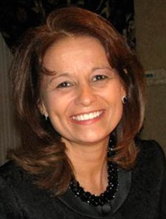
Lisa presented her work on inclusive practices at the LEAP Convening: Building Inclusive and Equitable Learning Opportunities on March 16, 2018. Lisa is a Professor and Lockheed Martin Eminent Scholar at the University of Central Florida. Her primary area of research focuses on collaboration between general and special education, with a specific interest in the unique opportunities that exist for students in urban and rural settings. She has a passion for connecting technology and simulation to impact teacher preparation and student learning. Lisa is the author of The Co-Planner (4th ed.): Two Professionals + One Plan for Co-Teaching.

Lisa is sought out regularly to provide national and international keynote addresses. She serves in numerous leadership roles including serving on the board of the Council for Exceptional Education Teacher Education Division where she was selected by the Council for Exceptional Children as the Child Advocate Network (CAN) coordinator of the year. She also has been the editor and associate editor for two international journals and is currently the Associate Editor of Teaching Exceptional Children.

The Co-Planner: Two Professionals + One Plan for Co-Teaching

Dieker, Lisa. The Co-Planner: Two Professionals + One Plan for Co-Teaching. Knowledge By Design: Whitefish Bay, WI, 2015. Print.

This unique lesson plan book is designed to be completed and shared between a general education teacher and a special education teacher.
The fourth edition of this best-selling plan book has been revised and updated to gather evidence of academic and behavioral adaptations as required by IDEA. In addition, planning tools for standard and modified assessment will facilitate efforts to monitor student performance and achievement goals.
Includes weekly strategies and monthly notes from the author that offer insight about the value, the art, and the impact of co-teaching. Supports 36-weeks.

More information about Lisa can be found on her website: Lisa Dieker’s Website

